Question No : 1
Write a blog on Difference between HTTP1.1 vs HTTP2

HTTP - HyperText Transfer Protocol.

Difference between HTTP1.1 vs HTTP2

1 | In HTTP/1.1, flow control relies on the underlying TCP connection. When this connection initiates, both client and server establish their buffer sizes using their system default settings.  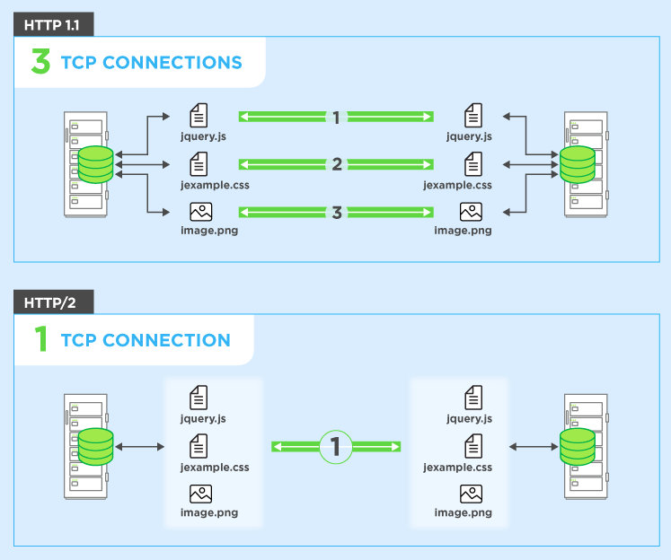 | HTTP/2 multiplexes streams of data within a single TCP connection. As a result, receive windows on the level of the TCP connection are not sufficient to regulate the delivery of individual streams. HTTP/2 solves this problem by allowing the client and server to implement their own flow controls, rather than relying on the transport layer.
2 | It is used a series of ordered, blocking connections in multiplexing.  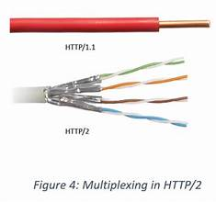 | It is used to allows multiple requests and responses to be sent concurrently on a single connection, reducing latency and speeding up page loading
3 | It is relies on plain text, which is less efficient in terms of data transfer and parsing.  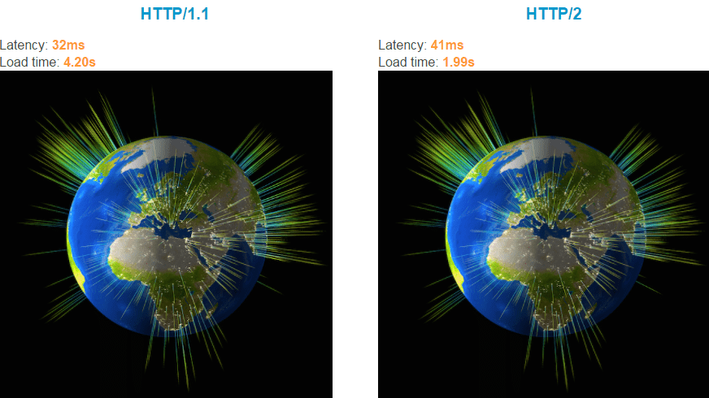 | It is a binary framing format that is more streamlined and faster than HTTP1.1
4 | It is taking more time to respond  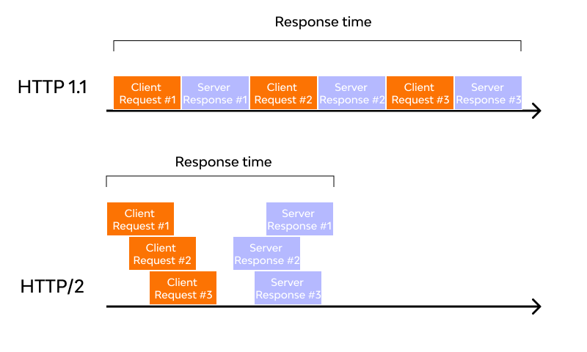 | It is taking less respond time comparing to HTTP1.1

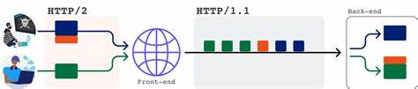
HTTP/2 is a significant step forward in web communication, offering numerous improvements over its predecessor, HTTP/1.1. While it has not achieved universal adoption, its advantages in terms of speed and efficiency make it a compelling choice for web developers and administrators.
HTTP/2 has become increasingly popular, with some estimates suggesting that around a third of all websites in the world support it. 

